1. bash: simple.sh: command not found
2. bash: ./simple.sh: command not found
3. 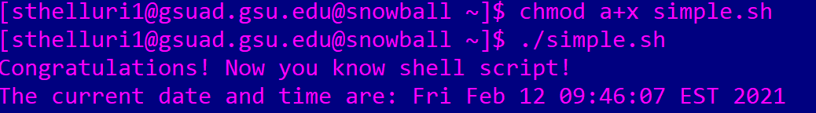
4. It ensures that the resultant date and time are printed on the same line as the string as opposed to the next line.
5. Yes, #Simple Script is a comment.
6. No, #!/bin/bash is not a comment, as it instructs the script to use the bash shell. It is mentioned on the first line.
7. I have 6 directories. 
8. There are no errors here, as the current working directory has been added to the path. The file to be executed is in the current working directory and does not need to be specified.
9. No, I am not able to find it.
10. Yes, we have a “command not found” error because the path was not specified and the path variable was not assigned to the current working directory.